Murdered to Death by Peter Gordon is the first play in his ‘Inspector Pratt’ series. A delightful send up of the murder mystery genre.

We take a step back in 1930’s high society where a group of friends are gathering together for a weekend of fun. Things soon take a turn with relations revealed, convincing con artists and dangerous liaisons. Can the bungling Inspector Pratt overcome his own incompetence and solve the murder.

[https://kilmacolmdramaticsociety.co.uk/**murdered-to-death-spring-2024**/](https://kilmacolmdramaticsociety.co.uk/?page_id=3957&preview=true)

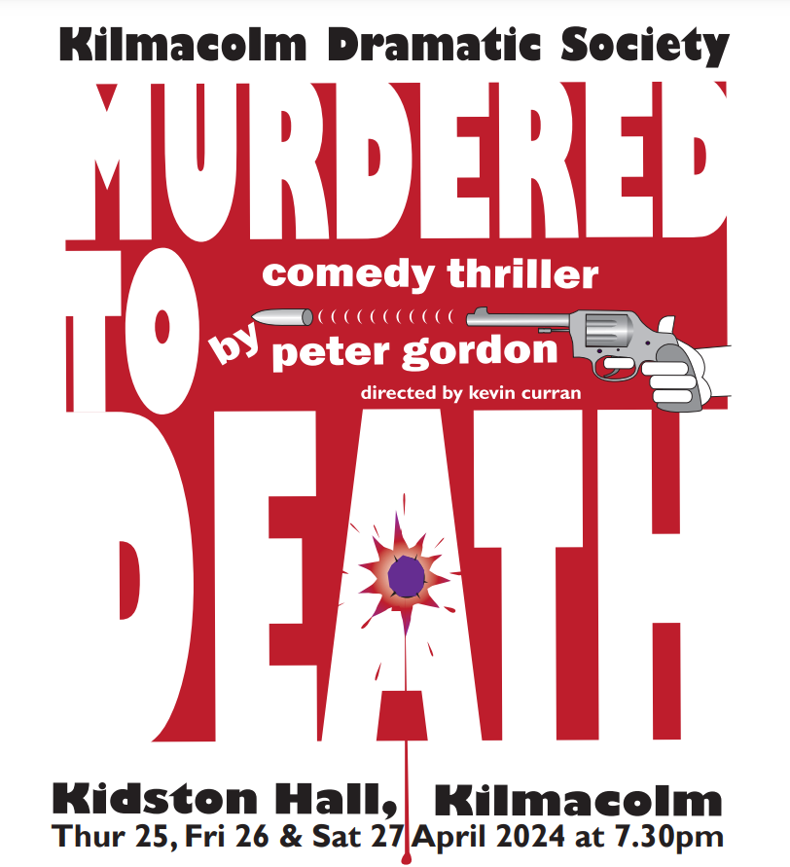

Can Constable Thompkins and his bumbling Inspector Pratt figure out who done it.

Can the bungling Inspector Pratt overcome

**Peter Gordon**

The first in the ‘Inspector Pratt’ trilogy of spoofs of the Agatha Christie ‘whodunnit’ genre.

The play introduces the inept and bungling Inspector Pratt, who battles against the odds and his own incompetence to solve the murder of the house’s owner. It soon becomes clear that the murderer isn’t finished yet; will the miscreant be unmasked before everyone else has met their doom or will the audience die laughing first?

We take a step back in 1930’s high society where a group of friends are gathering together for a weekend o fun. Reminiscing of good time, things soon take a turn with relations revealed, convincing con artists and dangerous liaisons. Can Constable Thompkins and his bumbling Inspector Pratt figure out who done it.

Murdered to Death **Peter Gordon**

The first in the ‘Inspector Pratt’ trilogy of spoofs of the Agatha Christie ‘whodunnit’ genre.

The play introduces the inept and bungling Inspector Pratt, who battles against the odds and his own incompetence to solve the murder of the house’s owner. It soon becomes clear that the murderer isn’t finished yet; will the miscreant be unmasked before everyone else has met their doom or will the audience die laughing first?

We take a step back in 1930’s high society where a group of friends are gathering together for a weekend o fun. Reminiscing of good time, things soon take a turn with relations revealed, convincing con artists and dangerous liaisons. Can Constable Thompkins and his bumbling Inspector Pratt figure out who done it.